Chuanjie ZANG

699382953

Step 1 :Open the Assignment 5 Base.ai file. Copy the placeholder.txt file, select 'type tool' and drag a enough text area in the black area below the poster. Set type color to 'white'. Open the 'Area Type Options' and set the column to 3.

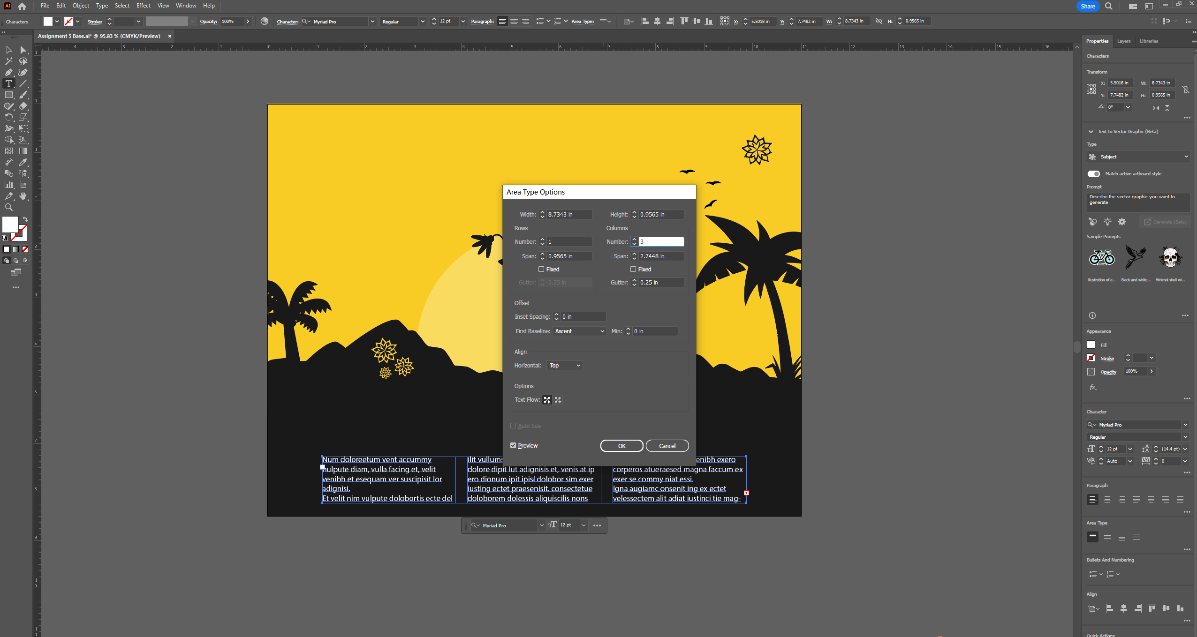

Step 2 :Adjust and use the Align function so that the text box is in the middle of the left and right side of the poster.

Step 3 : in properties panel, set front to 'sylfaen'

Step 4 : Select 'type tool', type 'Transform Yoga Sale!' at the top of the poster, select 'effect - wrap - arc '. Adjust the size and curvature of the text. When the text is large enough, the text and black elements overlap each other, so I need to give the text a stroke the same colour as the background colour.

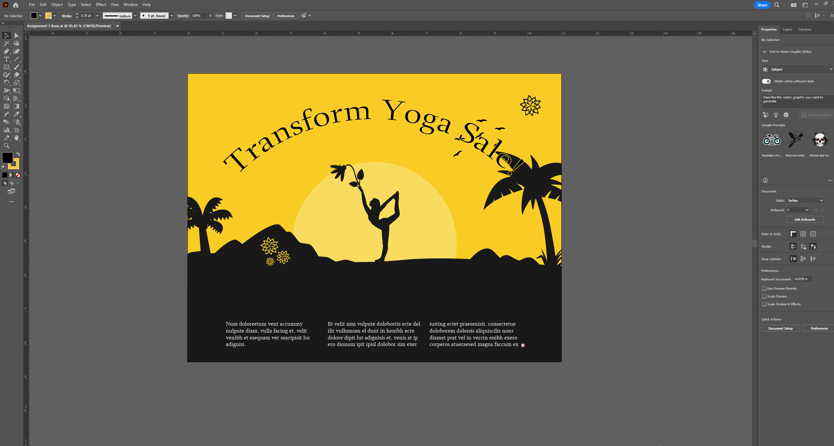

Step 5 : Select 'type tool' and type what you need in 'yoga_pc.doc' on the left and right side of the sun. Then select the 'sun' pattern, choose 'object - text wrap - make', make the text content wrap around the sun, through the 'text wrap option 'in the settings to adjust the distance between the text and the sun. Here I set the text around the sun to 'Arial' font, and set 'what:, when:, where:' to bold.

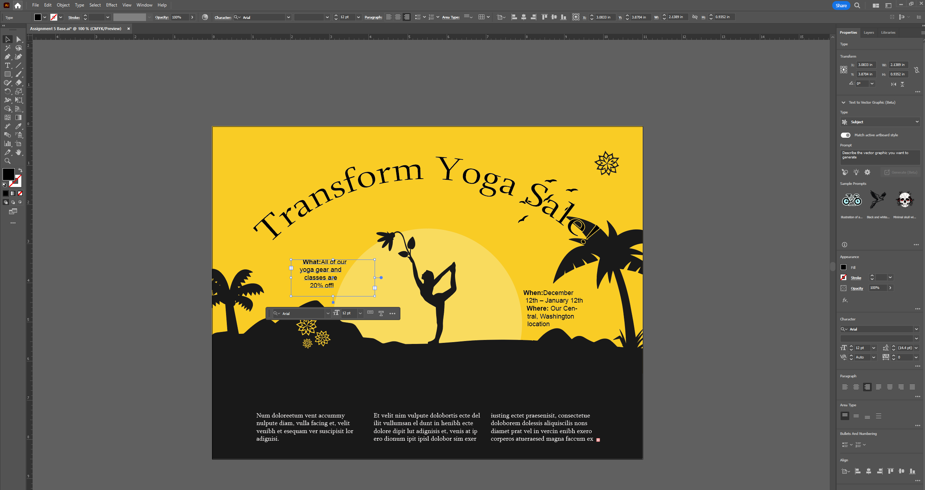

Step 6 :Select View > Outline to see all the paths on the page. Select the 'type tool' and add text to the spiral in the top right corner, then select Type > Type On A Path > Type On A Path Options to change the properties.

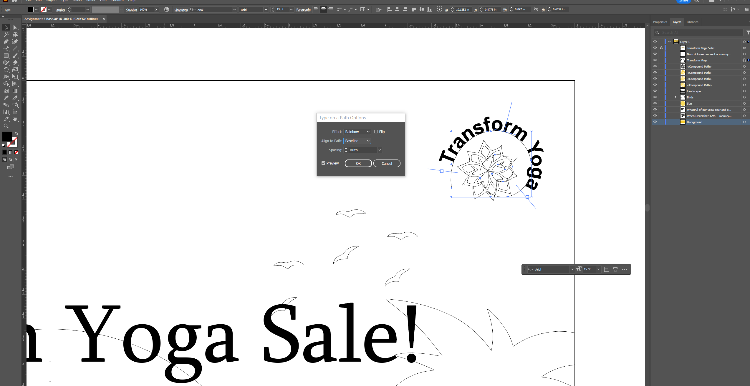

Step 7 :Cancel the outline view, add the last paragraph of text from 'yoga_pc.doc' to the middle of the poster and set the font colour to be the same as the background.

